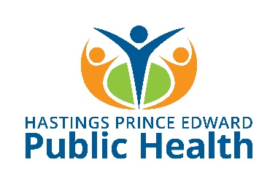
Sample Guideline for Screen-Free Recess Breaks

*Please adapt this Guideline to best meet the needs of your school

________________________________ School

Screen-Free Recess Break Guideline

Introduction
At _____________________ School, we believe that technology can be a powerful tool to enhance learning. It is now common for students to carry personal electronic devices (e.g. smart phones, tablets) to school. These devices can be used in many beneficial ways such as organizing information or participating in school-based learning platforms. However, at _________________________ School we also believe in the importance of supporting student well-being and acknowledge the connection between health and learning. With this in mind, we have developed the Screen-Free Recess Break Guideline to support our students in taking time in the day to turn off their screens and engage in opportunities for physical activity and social interaction.

Background
‘Screen time’ is time spent using a screen-based device, such as a smart phone, tablet, computer or TV. Not all screen time is unhealthy. Screens can offer an important way to learn and communicate at school and at work. However, a lot of the recreational use of screens has people sitting or lying down. This is called sedentary screen time and many children are getting too much of it.
Screen Time affects many aspects of children’s health. While research is still emerging, it is suggested that higher screen time can be linked to:
- Poor development of cognitive, language and attention skills during child’s early years
- Lower levels of physical fitness
- Lower levels of healthy weights
- Increased chance of developing cardiovascular disease and diabetes
- Behavioural issues, lower self-esteem and psychological well-being

Guideline
Students at __________________ School will be permitted to bring personal devices to school, with use for educational purposes in adherence to school board policy and teacher specific classroom contracts and provided that the devices will not be used during recess time.

Implementation Plan
This guideline will be implemented effective (date) _____________________.
Steps to implementation:
- School staff education and endorsement
- Parent community informed of new guideline (e.g. School Council meeting, information in school newsletter, parent evening presentations, etc.)
- Students informed of new guideline (e.g. teacher/principal discussing with each class before guideline is implemented, posters in hallways, morning announcements, student leadership team campaign, etc.)
- Support programs put in place to support students for screen-free recess (e.g. Active Recess playground games shared with other students, P.A.L.S. program, new equipment provided at recess, etc.)

Enforcement
Recess breaks are an important time for students to be physically active and for positive social interaction. Students found using personal devices during recess time may have the device confiscated by school staff. Parents will be contacted, and the student will not be permitted to bring the device to school.

We are committed to providing accessible publications, programs and services to all. For assistance please call 613-966-5500; TTY: 771 or email accessibility@hpeph.ca. For more information, please visit hpePublicHealth.ca.

